Constraint-Based Problem Solving
University Exam Scheduling

a) PEAS Description of the Exam-Scheduling Agent
The scheduling agent is modelled as a rational agent that reads the enrolment-conflict data and assigns an exam slot to every course.
PEAS Element | Description
Performance measure | All 7 conflicting pairs are placed in different slots (zero clashes); all 5 exams are assigned to one of the 3 slots; timetable produced with minimum search effort (few assignment attempts and backtracks).
Environment | 5 courses (A, B, C, D, E); 3 exam slots (Slot1, Slot2, Slot3 – one per day); the conflict list A–B, A–C, B–C, B–D, C–D, C–E, D–E. The environment is fully observable, deterministic, static, discrete, known and single-agent.
Actuators | Assign a slot to a course; change/undo (backtrack) an assignment; output/publish the final exam timetable.
Sensors | Reads the course list, the student-enrolment conflict data, the available slots and the current (partial) assignment of slots to courses.

b) Agent Type Classification
Best-suited agent: Goal-based agent (with a model of the constraints).
Justification:
- A simple reflex agent reacts only to the current percept. Choosing a slot for one course depends on the slots already given to its conflicting courses (e.g. C must differ from A, B, D and E), so fixed condition–action rules cannot guarantee a conflict-free timetable.
- A model-based agent keeps internal state (the partial timetable), but state alone does not tell it what to achieve; the task has an explicit goal.
- The goal is clear and testable: a complete assignment in which all 7 conflicting pairs have different slots. The agent must search through sequences of assignments (try, check, undo) until the goal test is satisfied – exactly what a goal-based agent does.
- A utility-based agent is not required: any conflict-free timetable is equally acceptable, there is no cost or preference to maximise, so success is simply goal satisfied or not.

c) CSP Formulation and Constraint Graph
- Variables: X = {A, B, C, D, E}, where A = Artificial Intelligence, B = Database Systems, C = Computer Networks, D = Operating Systems, E = Software Engineering.
- Domains: D(A) = D(B) = D(C) = D(D) = D(E) = {Slot1, Slot2, Slot3}.
- Constraints (binary, inequality): A ≠ B, A ≠ C, B ≠ C, B ≠ D, C ≠ D, C ≠ E, D ≠ E (7 constraints; the courses in each pair must get different slots).
- Constraint graph – Vertices: {A, B, C, D, E}
- Constraint graph – Edges: {(A,B), (A,C), (B,C), (B,D), (C,D), (C,E), (D,E)}
Constraint graph:
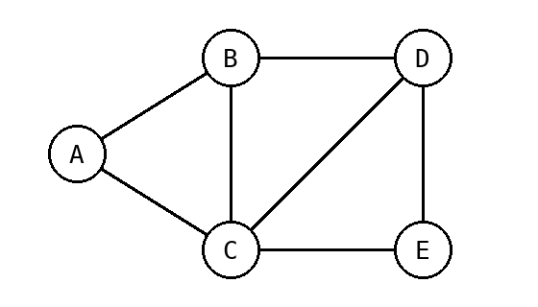
Vertex | Adjacent vertices (conflicts) | Degree
A | B, C | 2
B | A, C, D | 3
C | A, B, D, E | 4
D | B, C, E | 3
E | C, D | 2
Note: A–B–C, B–C–D and C–D–E form triangles, so at least 3 different slots are needed; this is a graph-colouring problem with 3 colours.
Python implementation (problem formulation):
import copy, json

VARS = ["A", "B", "C", "D", "E"]
SLOTS = ["Slot1", "Slot2", "Slot3"]
EDGES = [("A", "B"), ("A", "C"), ("B", "C"), ("B", "D"),
("C", "D"), ("C", "E"), ("D", "E")]
NEIGHBORS = {v: [] for v in VARS}
for x, y in EDGES:
NEIGHBORS[x].append(y)
NEIGHBORS[y].append(x)

d) Plain Backtracking Search
Method: static variable order A → B → C → D → E; values tried in the order Slot1 → Slot2 → Slot3. A value is accepted only if it does not conflict with an already assigned neighbour; otherwise it is rejected and the next value is tried. If all values of a variable fail, the search backtracks to the previous variable.
Step | Assignment attempt | Consistency check | Result | Current assignment
1 | A = Slot1 | No conflict | Assigned | {A=Slot1}
2 | B = Slot1 | Conflict with A = Slot1 | Rejected | {A=Slot1}
3 | B = Slot2 | No conflict | Assigned | {A=Slot1, B=Slot2}
4 | C = Slot1 | Conflict with A = Slot1 | Rejected | {A=Slot1, B=Slot2}
5 | C = Slot2 | Conflict with B = Slot2 | Rejected | {A=Slot1, B=Slot2}
6 | C = Slot3 | No conflict | Assigned | {A=Slot1, B=Slot2, C=Slot3}
7 | D = Slot1 | No conflict | Assigned | {A=Slot1, B=Slot2, C=Slot3, D=Slot1}
8 | E = Slot1 | Conflict with D = Slot1 | Rejected | {A=Slot1, B=Slot2, C=Slot3, D=Slot1}
9 | E = Slot2 | No conflict | Assigned | {A=Slot1, B=Slot2, C=Slot3, D=Slot1, E=Slot2}

Observation: four attempts were rejected (B = Slot1, C = Slot1, C = Slot2, E = Slot1). Every variable found a legal value, so no variable ran out of values and no backtracking (undoing of an earlier assignment) was needed. Total assignment attempts = 9; backtracks = 0.
Final valid timetable: A = Slot1, B = Slot2, C = Slot3, D = Slot1, E = Slot2
Exam Slot | Courses
Slot1 (Day 1) | A (Artificial Intelligence), D (Operating Systems)
Slot2 (Day 2) | B (Database Systems), E (Software Engineering)
Slot3 (Day 3) | C (Computer Networks)
Python implementation of plain Backtracking:
log = [] # trace used for the report tables
counter = {"attempts": 0, "backtracks": 0, "step": 0}

def fmt(assign):
return "{" + ", ".join(f"{v}={assign[v]}" for v in VARS if v in assign) + "}"

def backtracking(assign):
if len(assign) == len(VARS):
return assign
var = next(v for v in VARS if v not in assign) # static order A..E
for val in SLOTS: # Slot1 -> Slot3
counter["attempts"] += 1
counter["step"] += 1
clash = [n for n in NEIGHBORS[var] if assign.get(n) == val]
if clash:
print(f"Step {counter['step']:2d}: {var} = {val} -> CONFLICT with {clash[0]}={val}, rejected")
log.append((counter["step"], f"{var} = {val}", f"Conflict with {clash[0]} = {val}", "Rejected", fmt(assign)))
continue
assign[var] = val
print(f"Step {counter['step']:2d}: {var} = {val} -> consistent, assigned {fmt(assign)}")
log.append((counter["step"], f"{var} = {val}", "No conflict", "Assigned", fmt(assign)))
result = backtracking(assign)
if result:
return result
del assign[var]
counter["backtracks"] += 1
print(f" BACKTRACK: remove {var} = {val}")
return None

def report(name, sol):
print(f"{name} timetable : " + ", ".join(f"{v}->{sol[v]}" for v in VARS))
print(f"{name} assignment attempts : {counter['attempts']}")
print(f"{name} backtracks : {counter['backtracks']}\n")

print("---- Plain Backtracking ----")
sol = backtracking({})
report("BT", sol)
Output (Python IDE):
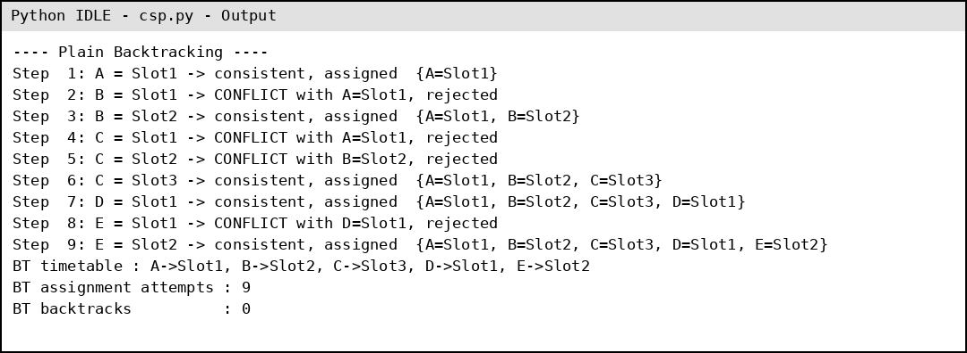

e) Backtracking Search with Forward Checking
Method: same variable order (A → B → C → D → E) and value order (Slot1 → Slot2 → Slot3). After each assignment, the assigned value is removed from the domains of the unassigned neighbours. If any domain becomes empty (wipe-out), the assignment is undone and the next value is tried. (S1, S2, S3 denote Slot1, Slot2, Slot3.)
Step | Assignment | Domains of unassigned variables after pruning | Values pruned | Result | Current assignment
0 | (initial) | A, B, C, D, E = {S1,S2,S3} each | — | — | { }
1 | A = Slot1 | B={S2,S3} C={S2,S3} D={S1,S2,S3} E={S1,S2,S3} | B: S1; C: S1 | Assigned | {A=Slot1}
2 | B = Slot2 | C={S3} D={S1,S3} E={S1,S2,S3} | C: S2; D: S2 | Assigned | {A=Slot1, B=Slot2}
3 | C = Slot3 | D={S1} E={S1,S2} | D: S3; E: S3 | Assigned | {A=Slot1, B=Slot2, C=Slot3}
4 | D = Slot1 | E={S2} | E: S1 | Assigned | {A=Slot1, B=Slot2, C=Slot3, D=Slot1}
5 | E = Slot2 | (no unassigned variables) | — | Assigned – complete | {A=Slot1, B=Slot2, C=Slot3, D=Slot1, E=Slot2}

Observation: no domain became empty, so no wipe-out and no backtracking occurred. Notice that after A = Slot1 the values Slot1 were already removed from B and C, so B = Slot1 and C = Slot1 were never tried. Likewise C was left with only {Slot3}, and E was left with only {Slot2} before it was assigned. Total assignment attempts = 5; backtracks = 0.
Final valid timetable: A = Slot1, B = Slot2, C = Slot3, D = Slot1, E = Slot2
Exam Slot | Courses
Slot1 (Day 1) | A (Artificial Intelligence), D (Operating Systems)
Slot2 (Day 2) | B (Database Systems), E (Software Engineering)
Slot3 (Day 3) | C (Computer Networks)
Python implementation of Backtracking with Forward Checking:
def forward_checking(assign, domains):
if len(assign) == len(VARS):
return assign
var = next(v for v in VARS if v not in assign)
for val in list(domains[var]):
counter["attempts"] += 1
counter["step"] += 1
new_dom = copy.deepcopy(domains)
new_dom[var] = [val]
wipeout = False
for n in NEIGHBORS[var]:
if n not in assign and val in new_dom[n]:
new_dom[n].remove(val)
if not new_dom[n]:
wipeout = True
assign[var] = val
left = {v: new_dom[v] for v in VARS if v not in assign}
txt = " ".join(f"{v}={{{','.join(s[-1] for s in d)}}}" for v, d in left.items())
if wipeout:
print(f"Step {counter['step']:2d}: {var} = {val} -> domain wipe-out, undo")
log.append((counter["step"], f"{var} = {val}", txt, "Wipe-out: undo", fmt(assign)))
del assign[var]
counter["backtracks"] += 1
continue
print(f"Step {counter['step']:2d}: {var} = {val} -> domains {txt if txt else '(none left)'}")
log.append((counter["step"], f"{var} = {val}", txt if txt else "(no unassigned variables)", "Assigned", fmt(assign)))
result = forward_checking(assign, new_dom)
if result:
return result
del assign[var]
counter["backtracks"] += 1
return None

print("---- Backtracking + Forward Checking ----")
full = {v: list(SLOTS) for v in VARS}
sol = forward_checking({}, full)
report("FC", sol)
Output (Python IDE):
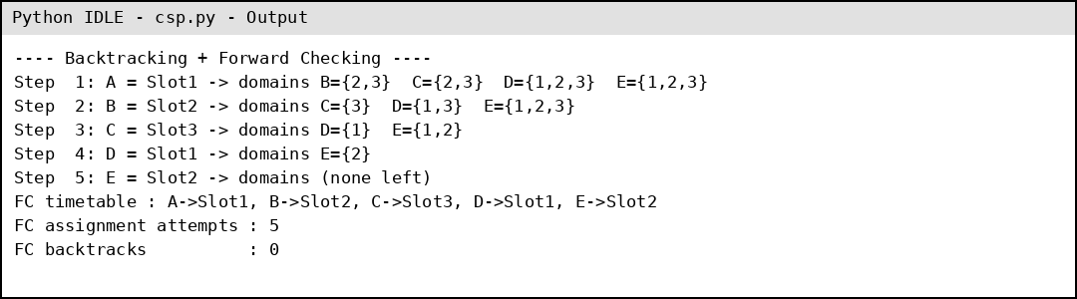

f) Comparison of Plain Backtracking and Forward Checking (20 Marks)
Criterion | Plain Backtracking | Backtracking + Forward Checking
Assignment attempts | 9 (5 accepted + 4 rejected) | 5 (all accepted)
Rejected / failed attempts | 4 (B=Slot1, C=Slot1, C=Slot2, E=Slot1) | 0 (these values were pruned in advance)
Backtracks | 0 | 0
Final timetable | A=Slot1, B=Slot2, C=Slot3, D=Slot1, E=Slot2 | A=Slot1, B=Slot2, C=Slot3, D=Slot1, E=Slot2 (same)
Overall efficiency | Checks conflicts only after choosing a value, so it wastes attempts on values that are already illegal. | Prunes illegal values immediately, so it needs about 44% fewer attempts (5 vs 9); slight extra work to update domains.

Why forward checking reduces the search effort:
- Plain backtracking discovers a conflict only when it tries a value; it can choose a value that already makes a future variable impossible and notice the problem much later.
- Forward checking looks ahead: after each assignment it deletes the now-illegal values from the neighbouring domains, so illegal values (such as B = Slot1, C = Slot1, C = Slot2, E = Slot1) are never tried.
- It detects dead ends early: if a neighbour's domain becomes empty, the current assignment is rejected immediately instead of continuing deeper and backtracking later.
- In this small problem the first-choice order happens to reach a solution without any backtracking in both methods, so the saving shows as fewer attempts (5 instead of 9). On larger or harder problems, where dead ends do occur, early detection avoids exploring whole failing branches and the saving is much greater.
Conclusion: Both methods give the same conflict-free timetable (A, D in Slot1; B, E in Slot2; C in Slot3), but Backtracking with Forward Checking is more efficient because it needs about 44% fewer assignment attempts and no rejected attempts, at the cost of a small domain-update overhead.

